DOCUMENT 24 — Privacy, DPDP Compliance & Data Governance
Visionary Internal · v1.0 · DPDP 2023 as the floor, not the ceiling

Consent gates every cross-person read. Erasure is a cascade, not a button.
Residency is India-only. These are architecture properties, verified by tests.

1. Consent & lawful basis
- Explicit consent at signup; verifiable parental consent for <18; consent history stored.
- Withdrawal = revoke cascade: parent/teacher/org reads cut within one session (Doc 18 KF4).
- Purpose limitation: L7 training use only after PII scrub + quality-filter approval;
raw conversations encrypted with a per-student KMS key before storage.

2. Data-principal rights
Access · correct · erase · grievance — exercised in-product via Memory & Privacy centers;
grievance-officer contact published; response SLA tracked in the audit log.

3. Retention & erasure cascade

Data | Retention
Session context (Redis) | 2h TTL
Interaction events (L7) | policy period; PII-scrubbed
SCM / memory namespaces | until erasure request
Backups | anonymized on next cycle
Erasure cascade ≤30 days: SCM → Qdrant namespaces → artifact share-links → L7 raw
(aggregate de-identified metrics retained only).

4. Security controls & RBAC
AES-256 at rest · TLS 1.3 in transit · per-student KMS keys · residency AWS ap-south-1
multi-AZ, no cross-border transfer · CloudTrail 90-day + SIEM anomaly alerting.
RBAC enforced server-side: student=self · parent=connected child · teacher=cohort
aggregate · org=aggregate-only · admin=scoped.

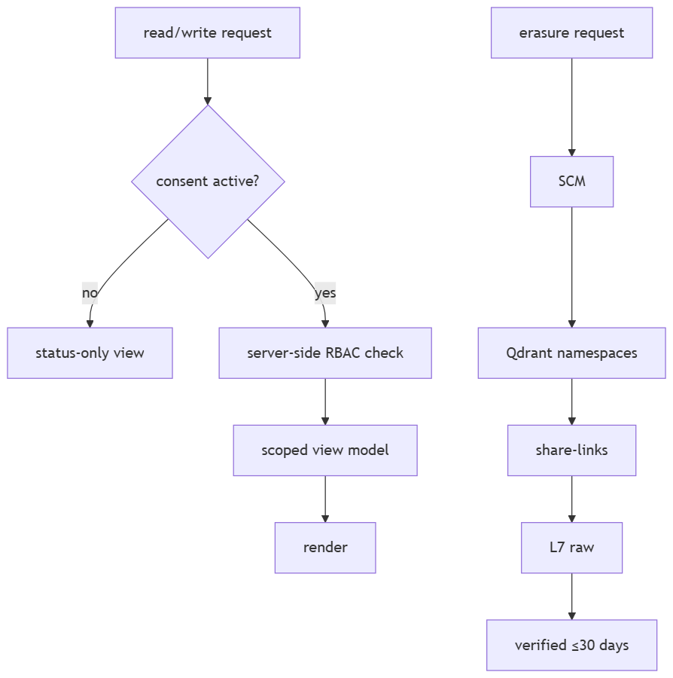

5. Breach & audit
Breach notification per DPDP timelines; audit log covers membership, permission and
transition events (Doc 19); anomalous access triggers SIEM alert + review.

OKF
KF1 parental consent enforced <18 on every cross-person read · KF2 erasure cascade verified
≤30 days · KF3 zero PII in training sets (sampled audit) · KF4 RBAC enforced server-side in
contract tests · KF5 100% data resident in ap-south-1.

